

DEPARTMENT OF ELECTRICAL ENGINEERING & ELECTRONICS

Final report for project ‘A passive automobile collision warning system’

Author: Weizhou Wen (201448566)

Project Supervisor: Yaochun Shen

Project Assessor: Paul Bryant

Declaration of academic integrity

The standard University of Liverpool statement of academic integrity [6] should go here as follows:

I confirm that I have read and understood the University’s Academic Integrity Policy.

I confirm that I have acted honestly, ethically and professionally in conduct leading to assessment for the programme of study.

I confirm that I have not copied material from another source nor committed plagiarism nor fabricated, falsified or embellished data when completing the attached piece of work. I confirm that I have not copied material from another source, nor colluded with any other student in the preparation and production of this work.

SIGNATURE……………Weizhou Wen…………………………….......................................…………… DATE……… 14th April 2021………………………….

Content

Abstract 3

Project Specifications 3

The Original Project Specification 3

Original Verification Table 3

Major Revisions 4

Introduction 4

Literature Survey 5

Industrial Relevance, Real-world Applicability and Scientific/Societal Impact 7

Theory 8

Thin lens camera model 8

Pinhole camera model 10

Design 11

Hardware 11

Software 12

Graphical User Interface (GUI) 24

Experimental Method 25

Results and Calculations 27

Discussion 34

Conclusions 35

References 36

Appendices 38

Appendix 1(original milestones and original work package) [1] 38

Appendix 2(original Gantt Chart) [1] 41

Appendix 3(revised work package) 43

Appendix 4(revised Gantt Chart) 43

Appendix 5: MATLAB code of project4.m(image process) 44

Appendix 6: image acquisition code of first methods and graphical user interface 45

Appendix 8: The code of the combined method 47

Abstract

The project is a passive automobile collision warning system. The project aims to design the device to provide accurate distance information on the front or rear cars to help the driver keep safe following distance and avoid car collisions. The device consists of a personal computer and two webcams. A MATLAB program is well designed to run the device. It can measure the accepted distance from 5 to 24 meters in a 1/24 model test. The program will calculate the safe distance based on the current speed. If the cars are too close, the program will warn the driver. The device is suitable to use on most built-up areas (speed of vehicle is less than 40 km/h). The program can provide a larger number of continuous measurements and the execution time is less than 1 second. A graphical user interface is designed in MATLAB to interact with the driver. In a model test, the device mainly achieves the objectives and provides distance information quickly. For common people, the device is accessible and affordable.

Project Specifications

The Original Project Specification

“The student aims to design a car collision device with a PC and two webcams. The webcams are powered by USB lines. The control program is programmed by MATLAB with a graphical user interface. Due to the danger of real vehicle test on real roads, a simulated test will be executed to test the program. A car model will be used to represent real vehicles. The distance also will be shrunk in equal proportion to replace real distance in the model test (1/24 scale size).

Two webcams are expected to take a video of the front cars and rear cars and transfer the videos to the PC. In the PC, the program is designed to measure the distance from other vehicles to the vehicle. Then, the accurate distance will be showed on the graphical user interface simultaneously when the distance is less than 150 meters. The error of the measurement should less than 3 meters. If the vehicle interval distance is smaller than the minimum safe following distance (3 second times the car speed), the driver will be reminded by the program. In the model test, all lengths will be scaling down with the same ratio (1/24).

It is expected all programming and model test will be finished by 5th January 2021. [1]”

Original Verification Table

Table 1: The Original Verification Table [1]

|  |  |
| --- | --- |
| Parameter | Verification |
| Measure the accurate distance simultaneously | Test in model test (1/24 scale size) |
| Results are shown on screen | Demonstration |
| Alert the driver when the distance is not safe | Demonstration |
| The error of measurement less than 3 meters(12.5 cm in model) | Comparison |

Major Revisions

1. A line chart is used to display the results.
2. For quick response, the device is designed to detect and display the distance of one side: rear or front
3. Error is expected to be controlled in the range of 5 percent off the expected results.

The original milestones are shown in Appendix 1. Meanwhile. The original Gantt Chart is illustrated in Appendix 2. Due to the unexpected problems, some work packages are delayed. Then, the Gantt Chart is revised in the interim presentation. The revised work packages and revised Gantt Chart are shown in the Appendix 3 and Appendix 4.

Introduction

According to the WHO report [2], car accidents caused many casualties and high property damage. Road safety is a chief problem for many drivers.

Aggressive driving is a critical factor in collision accidents. According to the transport department data in 2019[3], 3047 accidents are caused by aggressive driving. If drivers fail to keep a safe following distance and drive aggressively, severe collision accidents might happen. Because if the car in front slows down or stops suddenly, the vehicle following distance might not be enough to stop the cars. Then, the car in behind might rush into the car in front. Though the driver is protected by seat belt and airbag, a violent impact still might hurt or kill drivers and passengers. A device that can help the driver keep enough vehicle following distance is a better tool to prevent collision accidents and keep people from hurt.

Vehicle manufacturing companies have developed many driver assistance systems to avoid car collision accidents. For example, Subaru developed the eyesight system, which can detect the barrier and stop the car to prevent collision [4].

In the thesis, a camera-based car collision warning system is introduced. It consists of a personal computer and a USB webcam. The device is designed to estimate the vehicle following distance with a monopoly camera. A pretrained network detector and relevant image process MATLAB functions are used in the program. In theory, the pinhole camera model is used in the computer vision project for distance calculation. The design and experiment results are introduced in detail in the following sections. In the area of theory, the camera model and the mathematical formula are presented. The accepted results also are listed. Then, in the section of design, the hardware of the device is introduced as images. The flowcharts and words are used to explain the structure the MATLAB program. The codes of the MATLAB program is shown in the appendices. Some interim results also are presented to explain the image process steps. Then, in experiment methods, the hardware of the model test is shown in detail.

Additionally, the graphical user interface of the program is shown in the section. For the next part, the experiment results are presented in tables and graphs. Then, the experiment results error is compared in a line chart. In the discussion of the report, the significance of the project is assessed. Meanwhile, the potential future work is discussed. In the last conclusion part, the finished work and the knowledge and skills of the project is summarized.

Literature Survey

Highway Code requires drivers to keep a two-second gap to the car in front in moving traffic [5]. If the cars stop in a tunnel, drivers still need to keep a 5-meter car gap [5]. The reserved distance is designed to use as a stopping distance to prevent collision accidents.

Figure 1: Typical Stopping Distance [5]

If the car in front suddenly stops, drivers need about 0.8 second to react to the emergency [6]. In the time, vehicles still move in the original speed. The moving distance in the 0.8 second is defined “Thinking Distance” in the Figure 1. Then, it also cost seconds to stop vehicles by braking system. The distance is called “Braking distance.” The sum of Braking distance and Thinking distance is Stopping Distance. If the gap between vehicles is great than Stopping Distance, the drivers are more likely to stop the car safely and avoid a collision accident.

To keep the proper following distance, drivers might use many different skills. However, mastering the drive skills might cost many times for a novice. A camera-based driver assistance system might be helpful. According to the definition of SAE International J3016 standards, the device should be a level 1 driver assistance system [7].

Next, the objective of the project is ensured. To design a level 1 driver assistance system which is used for rear-ending collision warning, a MATLAB is programmed and tested. The device can provide the driver with accurate distance to the front cars or rear cars. If the following distance is less than the safe stopping distance, the program should alert the driver. If it is connected to the braking system, it should be allowed to slow down or stop the car directly when the situation is dangerous. The error of the result will be limited to 5 percent of the distance. Then, the processing time should be less than the reaction time of human.

The measurement based on an image requires the preprocessing of photos. Image process technology is a good tool for varies driving tasks [8]. It can remove the background irrelevant items and detect the edge of vehicles.

Meanwhile, artificial intelligence is widely used for vehicle recognition. For example, a deep convolution neural network is developed for vehicle recognition by X. Luo [9]. The neutral network analysis the features of image in different layer and obtained more accurate results. Considering the effect of pretrained network, a neural network is used in the projectfor vehicle detection.

Considering the experiment budget and the risk, the device is tested on a model test. Car model is used in the test. The detailed information is introduced in Experiment Methods section.

Pinhole model is a basic camera model which is widely used in computer vision [10]. As a result, pinhole model is used for calculation in the MATLAB program in the project.

Industrial Relevance, Real-world Applicability and Scientific/Societal Impact

Advanced driver-assistance systems are well developed and widely used for park, collision warning, driver monitor and cruise control. The device presented by the report is a kind of driver assistance system. There are many other kinds of driver assistance system. In the section, the adaptive cruise control, and anti-lock braking system, and collision avoidance system are introduced. The basic components and the effect of the components are presented. Meanwhile, the markets forecast of the markets of advanced driver-assistance system is shown in final.

For example, adaptive cruise control (ACC) is used to adjust vehicles speed to maintain the chosen distance to cars in front [11]. The ACC system using radar are employed in different type of Audi vehicles [11]. In Audi ACC system, if something trouble are detected, the driver will be warned by a jolt from ACC system [11]. According to Consumer Reports Website, ACC system also may consist of laser, radar, camera components [12]. The ACC system help the driver to deal with long-time boring driving. Then, most consumer are satisfied with the system and trust the ACC system [12].

Anti-lock braking system (ABS) is another kind of widely used advanced driver-assistance system. It is designed to prevent the wheels are totally locked by brake system. If the wheel is not total stop, the friction force between wheels and ground is bigger. As a result, it is used to reduce the braking distance and improve safety. The ABS consists of ABS speed sensor, valves, pump, controller [13]. According to the law of EU, ABS is mandatory in each new built car after 2004[14]. ABS did make a difference in the risk of accidents. For example, according to a study of Monash University, the data analysis of the Victorian and Queensland indicates that there is an 18 percent risk reduction in vehicle-to-vehicle collision accidents in vehicles with Anti-lock braking system [15].

Collision avoidance system, which is known as pre-crash system is widely used now. The device the project aimed to developed is a kind of simple collision avoidance system. In a complex collision avoidance system, radar, laser, and camera is used to detect possible collision accidents [16].

A single camera input forward collision warning system is developed by E. Dagan; O. Mano et al [17]. According to the report of E.Dagan[17], cameras are cheaper than radar sensors. Consequently, the camera might be an excellent sensor to detect the exit of barriers in front of vehicles. As a result, a single camera is used as the input of the device in the project.

The positive effect of employment of front collision system is proven by a study from Shanghai [18]. According to the study of Tongji University, the front collision system improves traffic efficiency and stability [18]. Then, front collision warning system is recommended to use in more vehicles in the future [18].

The device of the final year project is a kind of collision warning system. The input of the device is a camera. The device is designed to estimate the vehicle following distance and alert the driver if necessary.

The device is accessible and affordable to common people. According to the forecast market research report of Marketsandmarkets website [19], the market size of advanced driver assistance systems is anticipated to grow at a compound annual growth rate of 11.9% in 2020 to 2030. The rapid growth of the markets means abundant opportunities for new company. If the device of the project is improved in future work and pass strict field test in the future, it might be an affordable choice for driver of old cars to update their vehicles.

Theory

In the project, pinhole camera model is used for the calculation of the distance between vehicles. The pinhole camera model is the ideal situation of the thin lens camera model. In the section, the thin lens camera model is introduced at first.

Thin lens camera model

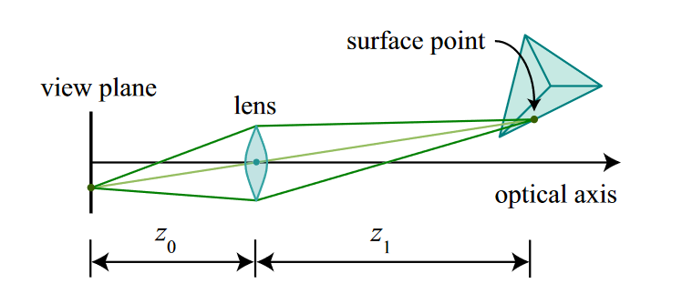

Figure 2: Thin lens camera model [20]

In the thin lens camera model,

$z_{1}$ is the distance from lens to object.

$z_{0}$ is the distance from lens to view plan.

$f$ is the focal length.

There is an equation for the above three parameters

$\frac{1}{\left|f\right|}$ = $\frac{1}{z_{0}}$ + $\frac{1 }{z_{1}}$ [20]

However， thin lens camera model is too complex for computer vision project. A simpler camera model might be more suitable for approximate calculation. Then, if the thin lens as aperture is consider as zero, the model is called Pinhole camera model [20], which is easier for image analysis and distance calculation.

Pinhole camera model

Figure 3: Pinhole Camera Model

In the pinhole camera model, the light from the object passes through a pinhole and arrive to the view plan. There is an equation for focal length and object distance:

$\frac{Vehicle Width}{Object distance}=\frac{Vehicle Width in photo }{Focal length}$ [10]

In the project, the vehicle's actual width will be estimated in advance because most vehicles have a similar width. Vehicle width in the photo will be measured by program. The focal length is a constant which can be measured by a coordinate experiment.

Then, the object distance will be calculated by the program because the device is installed on the vehicles. It is reasonable to consider the distance from other cars to the camera is approximately equal to the following distance of the user’s vehicle.

The unite of the vehicle width in the photo is pixel. The unit of focal length is millimeters. In the project, 1pixel = 0.2645833333 mm.

To measure the width of vehicles in front in photo, two methods are used.

The first method is the image process. In MATLAB, the image process function can detect the edge of the image. If there is a sudden change of value in the image matrix, the line of sudden change is identified as an edge. Next, open operation and close operation can remove the background and irrelevant items. After the gap of vehicles is filled, the program can measure the width of cars in images. The detailed process will be introduced in the Design section.

The second method is the pretrained network. There are many pretrained networks in the MATLAB toolbox. They can detect the image of the vehicle directly and output the width of the cars in pictures.

To minimize the program's error, two methods are both used in the project in different scope.

Design

Hardware

The device consists of a personal laptop and a USB webcam. The hardware are shown in following figures.

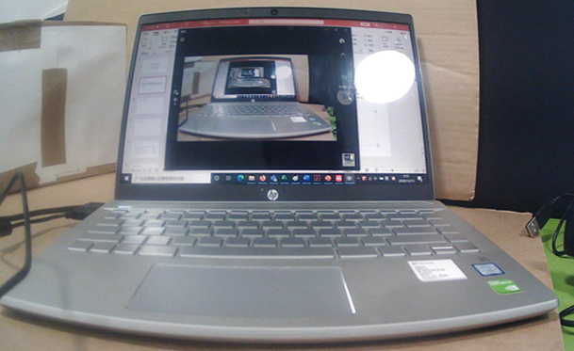Figure 4: Laptop

The relevant information of the laptop:

HP Pavilion Laptop

CPU: Intel Corei7 8th Gen

RAM: 8.00GB

Figure 5: USB webcam

The relevant information of the webcam:

Encoding Format: H.264 MJPEG

Video Resolution: The best resolution is 1920*1080. However, in the experiment, for a quick response, the resolution of the image is 640*480.

Frame Rate:30FPS

Power Supply: DC 5V. USB direct power.

Wide angle lens.

Software

In the first, the MATLAB program of image process method is developed and tested. The flowchart of the program code project4.m is shown in the following figure.

Figure 6: flowchart of program4.m(image process method)

The code of program 4 is shown in Appendix 5. The image acquisition code and graphical user interface are shown in Appendix 6. The graphical user interface will be introduced in detail in the Results section.

In the program, firstly, the program will turn the RGB colorful photo to grey photo:

Figure 7: The RGB photo taken by webcam

Firstly, the webcam takes a photo and submits the photo to the program.

Figure 8: grey photo after the first step

Secondly, in the MATLAB program, the image is transferred to a grey image for following processes.

Figure 9: edge detect

Thirdly, function “edge” and function “bwperim” is used to detect the edge of items in the photo.

男子的脸部特写与配字黑白照

Figure 10: closing

Fourthly, closing is used to remove some small item and fill the gaps and holes on the image.

Figure 11: opening

Fifthly, the effect of opening is similar to the effect of closing.

Figure 12: remove small items

Sixthly, the function” bwareaopen” is used to remove the small irrelevant white point in the image. The function bwareaopen is designed to remove small items. Compare to figure 11, the small white point in the top is removed in figure 12.

徽标

Figure 13: measure vehicle width in photo

In the last step, the program measures the width of the white area, which equates to the width of vehicles in the original image. The above process will not change the width of the white space of cars.

Another method is the pretrained network. In MATLAB automated driving toolbox, some pretrained network is ready to be trained for vehicles recognition tasks. For example, resnet50 is trained in student’s computer by MATLAB offered code and dataset [21]. The process is shown in the following figure. Meanwhile, the pretrained detector also are offered in the toolbox.

Figure 14: train process of a detector (1)

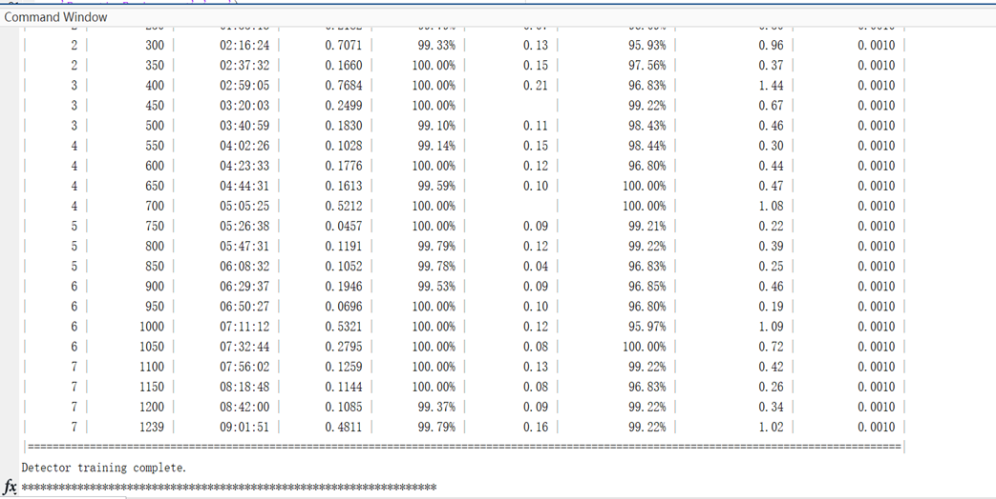Figure 15: train process of a detector (1)

The train process costs about 9 hours. Compare to the offered detector, the self-trained detector is more accurate. In the offered evaluation process [21], the average precision of offered detector is 0.64 and the average precision of self-trained detector is 0.67.

However, due to the problem of detector preserving and loading, the MATLAB offered detector is used in the program [22]. The program code is shown in appendix 7.

In the code, function “vehicleDetectorFasterRCNN” is used to load the pretrained Fast region based convolutional neural networks(RCNN) detector, which is offer by MATLAB toolbox [22].

The flowchart of the program is shown in the following figure:

Figure 16: The flowchart of method 2: pretrained detector

In the program, the safe following distance are calculated at first. The safe distance is based on the speed of the vehicles. Then, the pretrained detector is loaded. Next, a photo is taken by the webcam. The pretrained will detect the location of vehicles directly and output the width of vehicles in photos. The process is shown in the following figure. The result of the figure is 158 pixels.

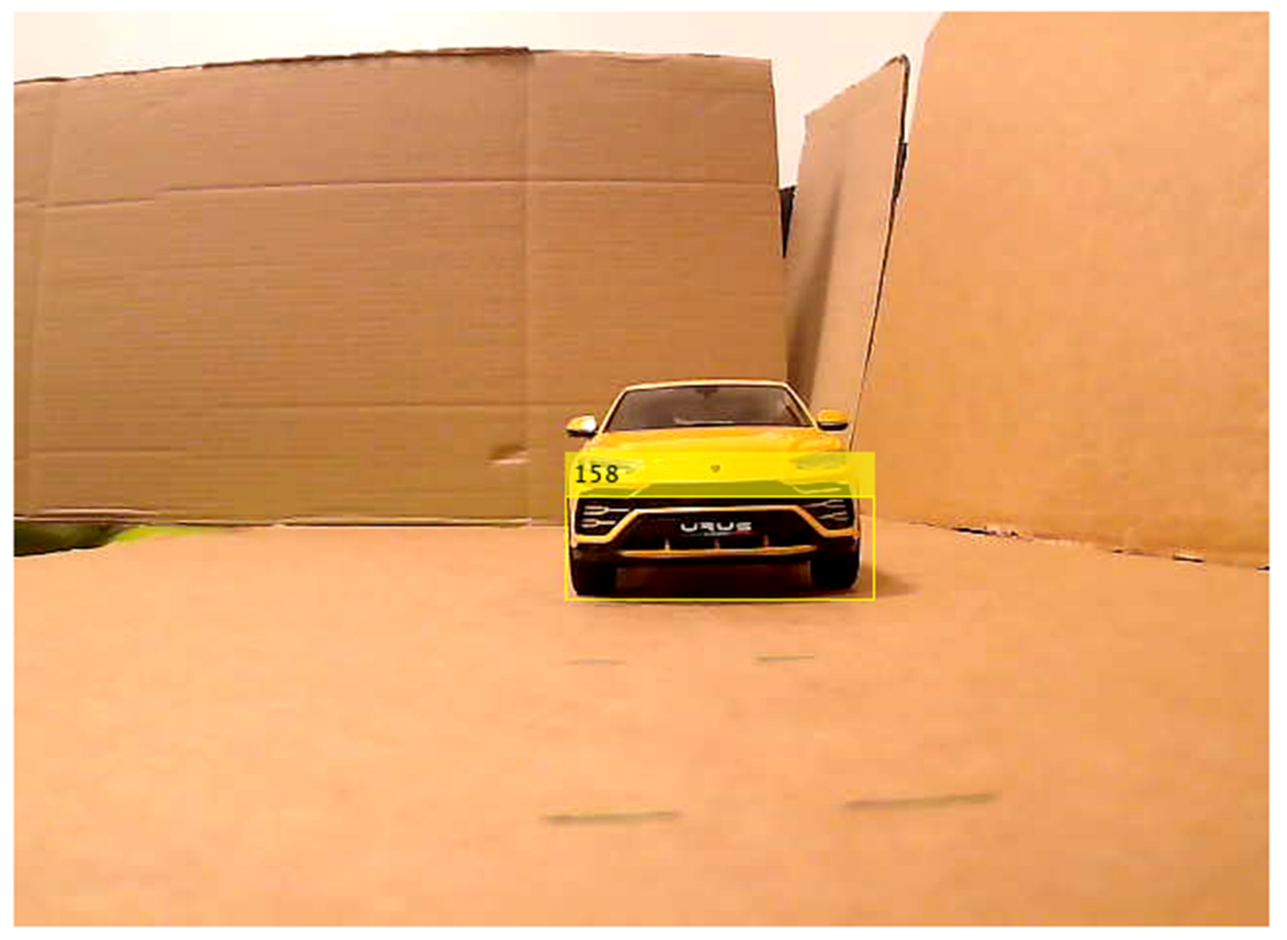Figure 17: The measure of the pretrain detector

Next, the actual following distance is calculated. If the results is smaller than the safe distance (threshold value), the program will consider it is dangerous and warn the driver. Otherwise, the program will display the signal of safe.

Based on the experiment results of the above two program codes, a combined method is generated to reduce the experiment error. The flowchart of the combined method is shown in the following diagram:

Figure 18: the flowchart of the combined method

The code of the combined method is shown in appendix 8.

In the new program, first, the user should input the speed of the vehicle. Then, the user should set the number of measurements. Then, the safe distance will be calculated and be regarded as the threshold value. Next，a pretrained detector is loaded from MATLAB toolbox. Then, the program will start a loop. In a loop, the program takes a photo with the webcam. Then, the program uses the pretrained detector to estimate the vehicle photo width. If the width is big (the following distance is small), the program will use the method of image process to make a more accurate measurement. Otherwise, the estimated result of pretrained detector will be used to calculate the actual following distance directly. In the last step, the program will judge whether the situation is safe or not and display the conclusion. The program will repeat the loop until finish the chosen number of measurements.

Graphical User Interface (GUI)

A graphical user interface is designed by MATLAB App designer. The graphical user interface is shown as illustration.

Figure 19: Graphical User Interface

In the top left corner, there is an edit area which named “Speed(km/h).” In the edit area, the user is expected to input a number which is the speed of the current vehicle. The unite of the value is km per hour. With the input value, the program will calculate the safe distance. Two-second following distance is required by law [5]. However, considering the possible special circumstances and the responding time of the program, three-second following distance is set to calculate the safe distance. Because in some special weather, the friction force between road and vehicles is smaller, a longer stopping distance is required. If longer stopping distance is required, the parameter of time is also easy to change in the MATLAB code. The result of safe distance is shown in the edit text area which is named:” Safe Distance(m).” The unite of the edit field is meter.

Meanwhile, before the program running, the user also is expected to input the number of measurements in the edit field called” the number of measurements.” The input value will be the number of measurements which will be executed by the program. In the combined methods program code, there is a loop in the program. In the loop, the program will take a photo firstly. Then, the program will process the photo and display the results. The program will repeat the loop continuously. The input value of edit field “the number of measurements” is the number of loops expected to finish by the program.

The edit field “Real Distance” is assigned to display the results of measurements. The results are also recorded in the following line chart.

In the left side of the graphical user interface, there is a line chart to display the results continuously. The y-axis is the results whose unit is meter. The range of axis depend on the range of measurement results. The x-axis is to show the number of measurements whose range is from 1 to the input value. After the user input the value of speed and the value of the number of measurements into corresponding edit field, the “Run” button should be pressed to start run the program. If the measurement result is greater than the safe following distance, the program will consider the situation is safe, the lamp is green and the edit field in the bottom right corner shows “It is safe.” Otherwise, if the result is smaller than the safe following distance, the situation will be considered dangerous. The lamp will turn to red. Meanwhile, the edit field in the bottom right corner will show a waring— “it is dangerous.”

Experimental Method

The hardware is mentioned in the Design section. Considering the budget of the project, a model test is executed to test the device.

The overall view of the model test is shown in illustration.

Figure 20: overall view of the model test.

In the right side of the overall, a yellow car model is used to simulate the real car. A USB transfer cable is placed to prevent car model from slide.

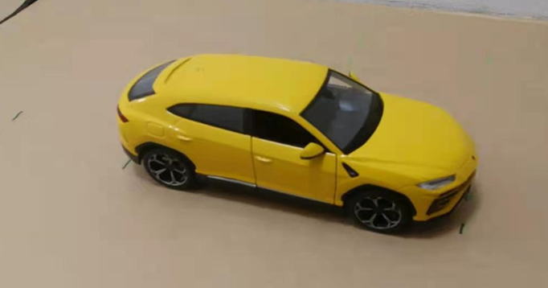

Figure 21: Lamborghini Urus car model

The ratio of model to real car is 1/24. As it shown in the overall view, the real side of the model is shown to the webcam. Because the device only observes the real view of the vehicles in front.

On the left side of the overview, a webcam is placed to take photo for the vehicle model. The USB webcam is connected to the laptop. Then, the MATLAB program is run in the laptop.

A soft tape is used to measure the distance from webcam to car model. The solution of the tape is 1 millimeter. The range of the tape is 150 millimeters. However, the random error of soft tape is possible in the measurement. In the model test, the displayed results are assigned to the actual distance in model test times the ratio 24. As a result, the final error might be amplified. The uncertainty is discussed in the discussion section.

墙上的海报

Figure 22: tape

Results and Calculations

In the model test, the model car is placed at distance from 20cm, 30 cm, 40 cm… to 110cm. After the above real distance times the model ratio, the accepted results are obtained.

Accepted Result= Real Distance in Model Test * Model Ratio (24)

The accepted results will be displayed in the program as the result of software. The distance in model test and the accepted distance are listed in the following table:

Table 2: distance in model test and accepted distance

|  |  |
| --- | --- |
| distance in model test(centimeter) | Accepted Distance(meter) |
| 20 | 4.8 |
| 30 | 7.2 |
| 40 | 9.6 |
| 50 | 12 |
| 60 | 14.4 |
| 70 | 16.8 |
| 80 | 19.2 |
| 90 | 21.6 |
| 100 | 24 |
| 110 | 26.4 |

Before the chart and illustration of experiment results and error, the formula of absolute error and precent error is presented.

Absolute Error = $\left|Expected Result-Experiment Result\right|$ [23]

Percent Error = $\frac{|Expected Result-Experiment Result|}{Expected Result}$ [24]

Percent Error is used to assess the accuracy of each measurement methods.

For the first method, the program of image process is executed firstly. Five times measurement in each distance, the results is shown in the following table:

Table 3：Experiment Results of the first methods.

|  |  |  |  |  |  |  |  |  |  |
| --- | --- | --- | --- | --- | --- | --- | --- | --- | --- |
| Accepted results(meter) | 4.8 | 7.2 | 9.6 | 12 | 14.4 | 16.8 | 19.2 | 21.6 | 24 |
| Experiment measurement results(meter) | 4.9973 | 7.0610 | 9.0150 | 11.0500 | 11.8000 | 13.5100 | 16.0941 | 16.8369 | 19.8982 |
| 4.9520 | 7.1530 | 9.0150 | 10.7300 | 12.6000 | 12.8753 | 16.5818 | 17.6516 | 19.5429 |
| 4.9520 | 7.1530 | 9.0150 | 10.7300 | 12.6000 | 12.4364 | 16.0941 | 17.6516 | 19.2000 |
| 4.9973 | 7.2000 | 9.0150 | 10.8400 | 12.2500 | 12.5793 | 16.5818 | 17.6516 | 19.5429 |
| 4.9520 | 7.1530 | 9.0450 | 10.8400 | 11.9000 | 12.5793 | 16.5818 | 17.6516 | 19.5429 |
| Average Experiment results(meter) | 4.970 | 7.144 | 9.021 | 10.838 | 12.230 | 12.796 | 16.387 | 17.489 | 19.545 |
| Variance(meter) | 0.000493 | 0.002054 | 0.000144 | 0.013656 | 0.1136 | 0.147863 | 0.057084 | 0.106198 | 0.048758 |
| Absolute Error of average results (meter) | 0.17012 | 0.056 | 0.579 | 1.162 | 2.17 | 4.00394 | 2.81328 | 4.11134 | 4.45462 |
| Percent error (%) | 3.5442 | 0.7778 | 6.0313 | 9.6833 | 15.0694 | 23.8330 | 14.6525 | 19.0340 | 18.5609 |

The graphs of percent error and variance are shown in figures as illustration.

Figure 23: Percent Error of the First Method

Figure 24: Variance of Experiment Results of the First Method

In the above two figures, a conclusion is obtained. With the increase of distance, the accuracy and the precision of the measurement are decreased. The experiment results become less accurate and unstable. As a result, the second method of pretrained network is tested for improvement.

Table 4：Experiment Results of the Second method.

|  |  |  |  |  |  |  |  |  |  |  |  |
| --- | --- | --- | --- | --- | --- | --- | --- | --- | --- | --- | --- |
| Accepted results(meter) | 4.800 | 7.200 | 9.600 | 12.000 | 14.400 | 16.800 | 19.200 | 21.600 | 24.000 | 26.400 | |
| Experiment measurement results | 3.207 | 9.167 | 11.458 | 13.279 | 14.956 | 16.521 | 17.985 | 20.297 | 22.552 | 23.680 |
|  | 6.259 | 9.536 | 11.551 | 15.115 | 16.715 | 16.331 | 18.944 | 20.894 | 28.416 | 25.833 |
|  | 6.232 | 10.846 | 11.366 | 11.840 | 15.613 | 15.964 | 18.944 | 22.200 | 26.311 | 26.311 |
|  | 6.639 | 19.463 | 11.366 | 13.929 | 15.613 | 17.327 | 18.452 | 22.200 | 24.081 | 26.808 |
|  | 6.578 | 10.371 | 11.276 | 15.115 | 15.444 | 19.200 | 21.859 | 21.859 | 22.200 | 24.926 |
| Average Experiment results | 5.783 | 11.876 | 11.404 | 13.856 | 15.668 | 17.069 | 19.237 | 21.490 | 24.712 | 25.512 |
| Variance(meter) | 1.686 | 14.742 | 0.009 | 1.515 | 0.332 | 1.335 | 1.846 | 0.584 | 5.530 | 1.224 |
| Absolute Error of average results (meter) | 0.983 | 4.676 | 1.804 | 1.856 | 1.268 | 0.269 | 0.037 | 0.110 | 0.712 | 0.888 |
| Percent error (%) | 20.479 | 64.949 | 18.788 | 15.463 | 8.807 | 1.598 | 0.191 | 0.510 | 2.967 | 3.365 |

Figure 25: Percent Error of the Second Method

Figure 26: Variance of Experiment Results of the Second Method

Based on the above figures and data table, a conclusion is reached. The pretrained detector in the second methods succeed to obtain an accurate measurement in the range from 14.400 to 26.400. In the range, the percent error of experiment measurement is less than 10 percent. However, in the accept distance 4.800, 7.200, 9.600. 12.000, the percent error is extremely large. As a result, combining the two methods might be a practice way to improve accuracy.

The results of the combined method are shown as illustration.

Table 5：Experiment Results of the combined method

|  |  |  |  |  |  |  |  |  |
| --- | --- | --- | --- | --- | --- | --- | --- | --- |
| Accepted results(meter) | 7.200 | 9.600 | 12.000 | 14.400 | 16.800 | 19.200 | 21.600 | 24.000 |
| Experiment measurement results | 7.153 | 8.826 | 10.625 | 17.327 | 16.715 | 17.118 | 19.463 | 20.894 |
|  | 7.153 | 9.120 | 10.625 | 12.875 | 19.463 | 18.944 | 21.859 | 20.894 |
|  | 7.153 | 9.120 | 10.625 | 16.146 | 19.200 | 21.527 | 22.552 | 23.292 |
|  | 7.153 | 9.120 | 10.523 | 16.146 | 19.463 | 22.552 | 21.859 | 23.292 |
|  | 7.153 | 9.120 | 10.944 | 15.964 | 18.695 | 18.695 | 20.894 | 23.292 |
| Average Experiment results | 7.153 | 9.061 | 10.669 | 15.691 | 18.707 | 19.767 | 21.325 | 22.333 |
| Variance(meter) | 0.000 | 0.014 | 0.021 | 2.218 | 1.071 | 3.940 | 1.146 | 1.380 |
| Absolute Error of average results (meter) | 0.047 | 0.539 | 1.331 | 1.291 | 1.907 | 0.567 | 0.275 | 1.667 |
| Percent error (%) | 0.654 | 5.613 | 11.096 | 8.968 | 11.352 | 2.955 | 1.272 | 6.947 |

Figure 27: Percent Error of the Combined Method图表, 折线图

描述已自动生成

Figure 28: Variance of Experiment Results of the Combined Method

Results comparison of the three methods

Based on the experiment results of the above three methods, the percent error of the three methods are compared.

Table 6: Percent Error of Three Methods

|  |  |  |  |  |  |  |  |  |  |  |
| --- | --- | --- | --- | --- | --- | --- | --- | --- | --- | --- |
| Accepted results(meter) | 4.800 | 7.200 | 9.600 | 12.000 | 14.400 | 16.800 | 19.200 | 21.600 | 24.000 | 26.400 |
| image process(%) | 3.544 | 0.778 | 6.031 | 9.683 | 15.069 | 23.833 | 14.653 | 19.034 | 18.561 |  |
| Pretrained Network Detector(%) | 20.479 | 64.949 | 18.788 | 15.463 | 8.807 | 1.598 | 0.191 | 0.510 | 2.967 | 3.365 |
| Combined(%) |  | 0.654 | 5.613 | 11.096 | 8.968 | 11.352 | 2.955 | 1.272 | 6.947 |  |

Figure 29: Line Chart Graph of Percent Error of Three Methods

Table 7: Variance of the Three Methods

|  |  |  |  |  |  |  |  |  |  |  |
| --- | --- | --- | --- | --- | --- | --- | --- | --- | --- | --- |
| Accepted results(meter) | 4.800 | 7.200 | 9.600 | 12.000 | 14.400 | 16.800 | 19.200 | 21.600 | 24.000 | 26.400 |
| image process(meter) | 0.000 | 0.002 | 0.000 | 0.014 | 0.114 | 0.148 | 0.057 | 0.106 | 0.049 |  |
| Pretrained Network Detector(meter) | 1.686 | 14.742 | 0.009 | 1.515 | 0.332 | 1.335 | 1.846 | 0.584 | 5.530 | 1.224 |
| Combined(meter) |  | 0.000 | 0.014 | 0.021 | 2.218 | 1.071 | 3.940 | 1.146 | 1.380 |  |

Figure 30: Line Chart Graph of Variance of Three Methods

From the above graph and table, it indicates that the combined method obtains a better accuracy than the first method and the second method. The first methods did obtain some accurate results at accepted distance 4.8-meter, 7.2-meter, 9.6-meter, 12-meter However, with the increase of distance, the area of vehicles in image become more and more smaller. As a result, it is more difficult for the program to measure the width of image. Then, the percent error is growing with accepted distance. On the other hand, the pretrained detector show a better performance in distance from 14.4 meter to 26.4 meter. However, the precision and accuracy of the second method is worse at distance 4.8 meter to 12 meters. The pretrained network is recognize the vehicles from the special feature of the vehicles. If the area of vehicle is too big in the image, it might be hard for pretrained network to identify the difference of vehicle and background. Meanwhile, the results of first method is stable than the results of second method.

To obtain a better accuracy, the combined method is used for the final device.

The Execution time of three methods.

Table 8: Execution time of the three methods

|  |  |
| --- | --- |
|  | Execution time |
| image process(s/frame) | 0.3 |
| Pretrained Network Detector(s/frame) | 0.6 |
| Combined(s/frame) | 0.73 |

The execution time of the three methods is less than the human reaction time [6]. As a result, the revised objective is realized.

Discussion

Three methods are tested in the program. Finally, the combined method is proven that it is more accurate. The program works stably and quickly. The graphical user interface succeeds in communicating with the user and display the results vividly. However, there are still some possible improvements worthy of future work. Some deficiency might also need more study and test.

The first flaws of the evaluation of the results are the error control of the final combined method. Though the use of the image process and pretrained network detector in the third method do reduce the percent error of the result, the percent error is still larger than 5 percent. As a result, the first objective of future work is to reduce the measurement error until the percent error is less than 5 percent.

A possible way to reduce the measurement error is to use the self-trained detector in the program. According to the pretrained detector's evaluation results, the self-trained detector achieved an average precision of 0.67. On the other hand, the offered pretrained detector only obtain an average precision of 0.64.

Another potential way to reduce the error is to use the radar sensor as the program's second input sensor. More input information might improve the accuracy and extend the scope of use. According to E.Dagan[17], it is a good idea to use cameras and radars simultaneously.

The second point of the results discussion is the execution time. Though the execution time is less than the human mean reaction time [6], the execution time is still longer than other advanced driver assistance systems. For example, another front collision warning system only takes 19.8 milliseconds per frame [25].

Simplification of the image process program might be a practical way to reduce execution time in future work.

The third point of future work is the scope of use of the device. According to the table results, the device's scope is 7.2 meters to 24 meters. However, according to highway code 126[5], at 70mph(112km/h), vehicles' least stopping distance is 96 meters. Moreover, if three-second or four seconds is used to calculate the following distance, the required following distance is longer. As a result, the scope of use of the program is expected to extend.

If the program can detect the barrier behind it, it might make a more significant difference in driver safety. It is a good idea to give the program ability to analyze the image from two cameras in the future work: one camera in front and one camera behind. The objective might be a work package for future work.

Conclusions

In the project, the knowledge of the image process and machine learning is understood. The functions of the image process and machine learning are used in the MATLAB program. The background of advanced driver assistance system markets is learned in the literature review process. In the learning process of machine learning, the transfer learning of network is attempted. In the assessment of experiment results, the definition of percent error, accuracy, precision is reviewed.

In the project, an effective device is designed. The program is capable of measuring the distance at a speed of 0.73 seconds per frame. The user range is from 4.8 meters to 24 meters. However, in future work, the execution time, scope of use, and accuracy are still worthy of improvement.

References

[1] Wen, Weizhou, Final Year Project Specification Report, University of Liverpool, October 2020

[2] (2020, Feb.7) Road traffic injuries[Online]. Available: <https://www.who.int/news-room/fact-sheets/detail/road-traffic-injuries> (accessed 4th April 2021)

[3] (2020, Sep. 30) Contributory Factors for Reported Road Accidents (RAS50) [Online]. Available: https://www.gov.uk/government/statistical-data-sets/ras50-contributory-factors (accessed 4th April 2021)

[4] Subaru EyeSight [Online]. Available:

<https://www.subaru.com/engineering/eyesight.html> (accessed 4th April 2021)

[5] (2019, Aug. 20) The Highway Code [Online]. Available: https://www.highwaycodeuk.co.uk/control-of-the-vehicle.html (accessed 4th April 2021)

[6] J. Khashbat et al, “Determining the Driver's Reaction Time in the Stationary and Real-Life Environments (Comparative Study) ,” in 2012 *7th International Forum on Strategic Technology (IFOST)*, Tomsk, Russia, Sept 18-21. 2012, pp 1-3, DOI: 10.1109/IFOST.2012.6357735

[7] Taxonomy and Definitions for Terms Related to Driving Automation Systems for On-Road Motor Vehicles, SAE J3016, 2018.

[8] U Handmann, T Kalinke, C Tzomakas, M Werner and W.v Seelen, “An image processing system for driver assistance,” Image and Vision Computing. vol. 18, no. 5, pp. 367-376, Apr. 2000. DOI: https://doi.org/10.1016/S0262-8856(99)00032-3

[9] X.Luo, R.Shen, J.Hu, J.Deng, L. Hu, and Q. Guan, “A Deep Convolution Neural Network Model for Vehicle Recognition and Face Recognition,” Procedia Computer Science, vol 107, pp 715-720, 2017. Available: DOI: 10.1016/j.procs.2017.03.153

[10] P. Sturm, (2016, Feb and 05), Pinhole Camera Model, [Online]. Available: https://link.springer.com/referenceworkentry/10.1007%2F978-0-387-31439-6_472 (accessed 5th April 2021)

[11] GP.Duba and T.Bock, *Adaptive Cruise Control*. ATZextra Worldwide 13, 56–59, 2008. DOI: https://doi.org/10.1365/s40111-008-0055-0

[12] (2019, Aug 05) *Guide to Adaptive Cruise Control* [Online]. Available: https://www.consumerreports.org/car-safety/adaptive-cruise-control-guide/(accessed 6th April 2021)

[13] Karim Nice (2000, Aug 23) *How Anti-Lock Brakes Work* [Online]. Available: https://auto.howstuffworks.com/auto-parts/brakes/brake-types/anti-lock-brake.htm (accessed 10th April 2021)

[14] D.Stockin (2019) *Are Anti-Lock Brakes a Mandatory Safety Feature?* [Online]. Available: <https://drivetribe.com/p/are-anti-lock-brakes-a-mandatory-A_I2LRctSd2qJNWA6_RAOg?iid=SkGxYuRbQp2f5ebDjGL9pQ> (accessed 6th April 2021)

[15] Burton, David Matthew, et al. "Effectiveness of ABS and vehicle stability control systems." RACV, Melbourne, Australia, Rep. 04/01, 2004. Available: https://research.monash.edu/en/publications/effectiveness-of-abs-and-vehicle-stability-control-systems

[16] W. Wu et al, (2016) *Collision Avoidance System* [Online]. Available: <https://www.sciencedirect.com/topics/computer-science/collision-avoidance-system> (accessed 11th April 2021)

[17] E. Dagan; O. Mano et al, “Forward collision warning with a single camera,” in *IEEE Intelligent Vehicles Symposium,* Parma, Italy, June. 14-15, 2004, pp 37-42. DOI: 10.1109/IVS.2004.1336352

[18] M. Zhu, X. Wang, J. Hu, “Impact on car following behavior of a forward collision warning system with headway monitoring,” *Transportation Research Part C: Emerging Technologies,* vol.111, pp 226-244, Feb.2020. DOI: <https://doi.org/10.1016/j.trc.2019.12.015>

[19] (2020, Jun). *ADAS Market by System (ACC, DMS, IPA, PDS, TJA, FCW, CTA, RSR, LDW, AEB, & BSD), Component (Radar, LiDAR, Ultrasonic, & Camera Unit), Vehicle (PC, LCV, Bus, & Truck), Level of Autonomy (L1, L2&3, L4, L5), Offering, EV, and Region - Global Forecast to 2030* [Online], Available: <https://www.marketsandmarkets.com/Market-Reports/driver-assistance-systems-market-1201.html> (accessed 13th April 2021)

[20] (2005) *Camera Models* [Online]. Available: <http://www.cs.toronto.edu/~kyros/courses/418/Notes/Camera.pdf> (accessed 6th April 2021)

[21] *Train a Deep Learning Vehicle Detector* [Online]. Available:

<https://www.mathworks.com/help/driving/ug/train-a-deep-learning-vehicle-detector.html#d123e21946> (accessed 7th April 2021)

[22] *vehicleDetectorFasterRCNN* [Online]. Available: https://www.mathworks.com/help/driving/ref/vehicledetectorfasterrcnn.html(accessed 7th April 2021)

[23] S. Glen (2016, Oct.25). *Absolute Error & Mean Absolute Error (MAE)* [Online]. Available: <https://www.statisticshowto.com/absolute-error/> (accessed 11th April 2021)

[24] Helmenstine, A. Marie (2020, Nov. 2). *How to Calculate Percent Error* [Online]. Available: <https://www.thoughtco.com/how-to-calculate-percent-error-609584> (accessed 11th April 2021)

[25] J Pyo, J Bang, Y Jeong, “Front collision warning based on vehicle detection using CNN,” in *2016 International SoC Design Conference* (ISOCC). Jeju, South Korea, Oct. 23-26, 2016, pp. 163-164, DOI: 10.1109/ISOCC.2016.7799842

Appendices

Appendix 1(original milestones and original work package) [1]

Milestones

1. Finish the background learning
2. The program can recognize cars from background
3. The program can map the edge of vehicles in the video
4. The program can measure the width of vehicles in videos.
5. The program can calculate the real distance
6. The program can show the results and remind the driver.

Work package

Table 9: Work Package 1

|  |  |
| --- | --- |
| Specification | Learning the basic knowledge of image processing |
| Measurable | Finish a video course of image processing in MATLAB |
| Achievable | Every experiment is repeated in MATLAB by student |
| Relevant | The learning of basic operations of image processing is essential to begin to work in the field |
| Time-bound | two weeks and three days |

Table 10: Work Package 2

|  |  |
| --- | --- |
| Specification | Literature review |
| Measurable | Review 8 literature and understand the basic methods |
| Achievable | Learn the background information and the objective of literatures. The details of technology might be neglected now. |
| Relevant | Literature review is essential to learn the mainstream methods in academic field and indicate the main direction of the project |
| Time-bound | One week |

Table 11: Work Package 3

|  |  |
| --- | --- |
| Specification | Learning the basic knowledge of machine learning |
| Measurable | Finish a video course of machine learning in MATLAB |
| Achievable | Every experiment will be repeated in MATLAB by student |
| Relevant | The learning of basic operations of machine learning is essential to understand relevant literature and start to program the control program of the device |
| Time-bound | one weeks |

Table 12: Work Package 4

|  |  |
| --- | --- |
| Specification | The recognition of vehicles in video |
| Measurable | The program is capable to mark the location of vehicles with a white square in a continuous video. |
| Achievable | Train the artificial intelligence many times |
| Relevant | After location of vehicles in photo, the program might measure the distance in videos |
| Time-bound | Two weeks |

Table 13: Work Package 5

|  |  |
| --- | --- |
| Specification | The edge detection of vehicles |
| Measurable | The background in the video and photos will be removed |
| Achievable | The function of edge detection can find the edge of object. Then, the outside of project will be adjust to white. |
| Relevant | The remove of background can make the photo easy to process. |
| Time-bound | One week |

Table 14: Work Package 6

|  |  |
| --- | --- |
| Specification | The measurement of the width of vehicles in videos |
| Measurable | The program can output the width of vehicles in photo which approximate the value measured by people. |
| Achievable | Some MATLAB functions can measure the width of vehicles |
| Relevant | The width in video (in unite of pixel) can be used to calculate the real distance |
| Time-bound | One week |

Table 15: Work Package 7

|  |  |
| --- | --- |
| Specification | The calculation of real distance |
| Measurable | The program can output the real distance in model test which approximate the value measured by people |
| Achievable | The math theorem of similar triangles |
| Relevant | Calculate of the result |
| Time-bound | One week |

Table 16: Work Package 8

|  |  |
| --- | --- |
| Specification | The display of result and the alert of possible collision |
| Measurable | The graphical user interface can display the result of real distance. The program can use icons and sounds to alert the driver. |
| Achievable | The graphical user interface functions of MATLAB and sounds functions. |
| Relevant | The final product of the project |
| Time-bound | Two weeks |

Table 17: Work Package 9

|  |  |
| --- | --- |
| Specification | Prepare for interim project presentation |
| Measurable | Prepare the PowerPoint and lecture of presentation |
| Achievable | Record the weekly progress and experiment results |
| Relevant | The interim summary of project |
| Time-bound | 13 days |

Table 18: Work Package 10

|  |  |
| --- | --- |
| Specification | The Model test and improvement |
| Measurable | Test the final product and improve for future work |
| Achievable | Improve the robustness of the devices |
| Relevant | The improvement for industrial potential |
| Time-bound | 30 days |

Table 19: Work Package 11

|  |  |
| --- | --- |
| Specification | Prepare for bench inspection |
| Measurable | Prepare the product and introduction |
| Achievable | Improve the product |
| Relevant | The inspection |
| Time-bound | 21 days |

Table 20: Work Package 12

|  |  |
| --- | --- |
| Specification | Prepare the final year report |
| Measurable | Prepare the final year project report |
| Achievable | Prepare the report |
| Relevant | The report of the project |
| Time-bound | 22 days |

Appendix 2(original Gantt Chart) [1]

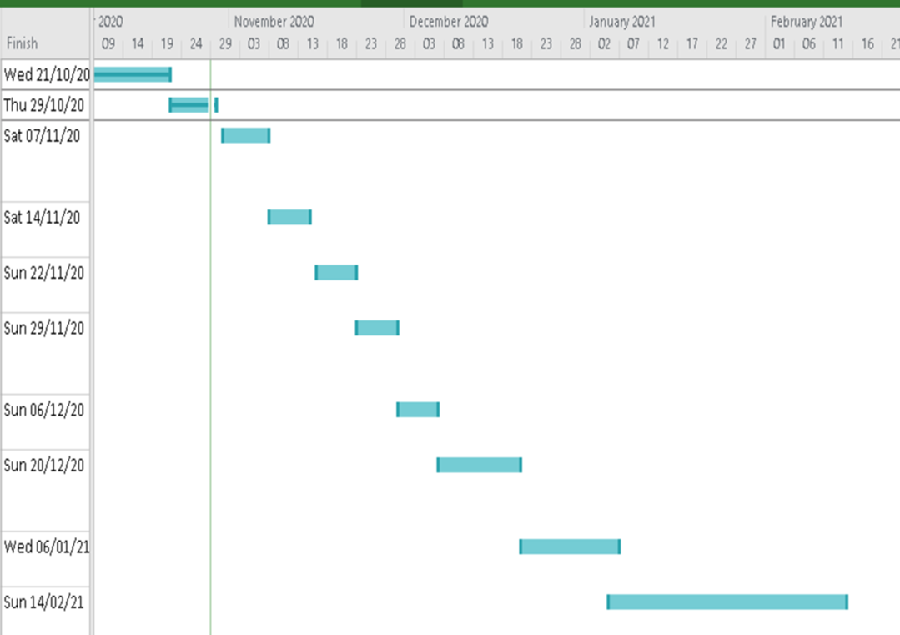

The basic knoeledge learning of image processing 13 days Mon 05/10/20 Wed 21/10/20

Literature Review 27 days Thu 22/10/20 Sun 29/11/20

Learn the basic knowledge of machine learning 7 days Sat 31/10/20 Sat 07/11/20

The recognition of vehicles in video 7 days Sun 08/11/20 Sat 14/11/20

The edge detection of vehicles 6 days Mon 16/11/20 Sun 22/11/20

The measurement of the width of vehicles in videoa 6 days Mon 23/11/20 Sun 29/11/20

The calculation of the real distance 6 days Mon 30/11/20 Sun 06/12/20

The display of results and the alert of possible collision 11 days Mon 07/12/20 Sun 20/12/20

Prepare for interim project presentation 13 days Mon 21/12/20 Wed 06/01/21

The Model test and improvement 30 days Tue 05/01/21 Sun 14/02/21

Prepare for bench inspection 21 days Mon 15/02/21 Mon 15/03/21

Prepare the final year report 22 days Wed 17/03/21 Thu 15/04/21

Appendix 3(revised work package)

|  |  |  |
| --- | --- | --- |
| Work Package 1 | | |
| Specification | The recognition of vehicles in video | |
| Measurable | The program is capable to mark the location of vehicles with a square in a continuous video in various environments. | |
| Achievable | Design and train the artificial intelligence. | |
| Relevant | After location of vehicles in photo, the program might measure the distance in videos | |
| Time-bound | 16 days (07/Jan/2021 to 14/Feb/2021) | |
| Work Package 2 | | |
| Specification | | The reduction of processing time |
| Measurable | | The processing time is less than 1 second |
| Achievable | | Improve the MATLAB program. |
| Relevant | | The collision waning system have to alert driver in time |
| Time-bound | | 10 days (15/Feb/2021 to 25/Feb/2021) |

Appendix 4(revised Gantt Chart)

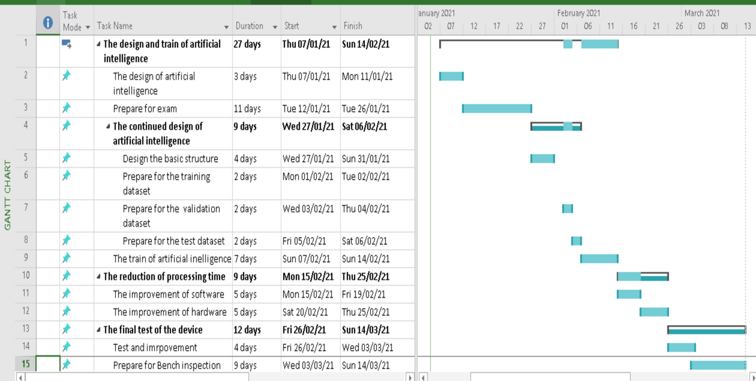Appendix 5: MATLAB code of project4.m(image process)

function [distance]=project4(I) % begin the function, input the photo

I1 = rgb2gray(I); % turn the RGB colorful image to grey image

I2=edge(I1,'prewitt'); % detect the edges in the image

I3=bwperim(I2);

se=strel('disk',10,4); % use close, open operation to remove the background and irrelevant small items

I4=imclose(I3,se);

I5=imopen(I4,se);

I6=bwareaopen(I5,2000);

I7=I6; % if necessary, function “infill” can be used in longer distance(I7=infill(I6,’holes’))

[Row, Col]=size(I7); % measure the width in photo

Sum=zeros([Row 1]);

for m=1:1:Row

for n=1:1:Col

Sum(m)=Sum(m)+I7(m,n);

end

end

wideth=max(Sum) ;

%Calculate the result

f=570;%based on 30 cm 590 pixels on 30 cm

distance=((8*f)/wideth)*0.24;

% results in meter, 0.24 is the expansion ratio of the model

end % end of function

Appendix 6: image acquisition code of first methods and graphical user interface

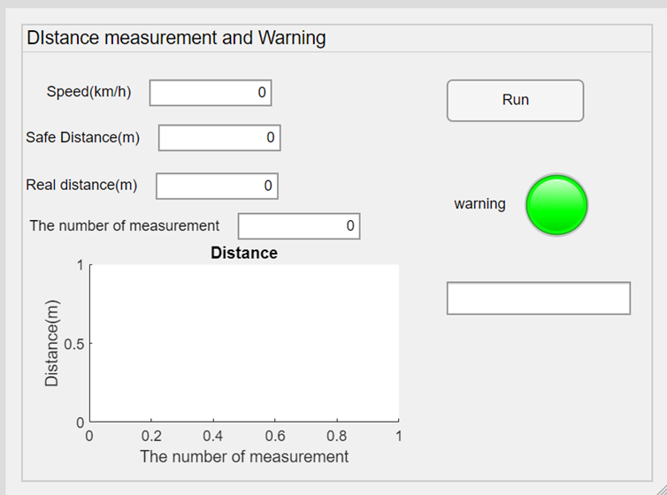

spe=app.SpeedkmhEditField.Value;%km/h

speed=spe/3.6;%m/s

safe=3*speed;

clear ca;

ca=webcam;

ca.Resolution='640x480';

mm=app.ThenumberofmeasurementEditField.Value;

distance=1:1:mm;

for n=1:1:mm

app.SafeDistancemEditField.Value=safe;

I = snapshot(ca);

distance(n)=project4(I)

%m in real

app.RealdistancemEditField.Value=distance(n);

app.ThenumberofmeasurementEditField.Value=n;

if distance(n)<safe

app.warningLamp.Color='r';

app.WarningTextArea.Value='It is dangerous';

else

app.warningLamp.Color='g';

app.WarningTextArea.Value='It is safe';

end

plot(app.UIAxes,distance)

end

Appendix 7

spe=app.SpeedkmhEditField.Value;%km/h

speed=spe/3.6;%m/s

safe=3*speed;

app.SafeDistancemEditField.Value=safe;

clear ca;

ca=webcam;

ca.Resolution='640x480';

fasterRCNN= vehicleDetectorFasterRCNN('full-view');

mm=app.ThenumberofmeasurementEditField.Value;

distance=1:1:mm;

for n=1:1:mm

I = snapshot(ca);

[bb,sc] = detect(fasterRCNN,I);

a=bb(1,3)

f=740;%based on 30 cm 530 pixels about 140mm

distance(n)=((8*f)/a)*0.24 %m in real

app.RealdistancemEditField.Value=distance(n);

app.ThenumberofmeasurementEditField.Value=n;

if distance(n)<safe

app.warningLamp.Color='r';

app.WarningTextArea.Value='It is dangerous';

else

app.warningLamp.Color='g';

app.WarningTextArea.Value='It is safe';

end

plot(app.UIAxes,distance)

end

Appendix 8: The code of the combined method

spe=app.SpeedkmhEditField.Value;%km/h

speed=spe/3.6;%m/s

safe=3*speed;

app.SafeDistancemEditField.Value=safe;

clear ca;

ca=webcam;

ca.Resolution='640x480';

fasterRCNN = vehicleDetectorFasterRCNN('full-view');

mm=app.ThenumberofmeasurementEditField.Value;

distance=1:1:mm;

for n=1:1:mm

I = snapshot(ca);

%I = imread('E:\study\FYP\project\testpicture\40cm.png');

%figure

%imshow(I)

[bb,sc] = detect(fasterRCNN,I);

a=bb(1,3)

if (a >90) % for 50 cm

distance(n)=project4(I)

else

f=740;%based on 30 cm 530 pixels about 140mm

distance(n)=((8*f)/a)*0.24 %m in real

end

app.RealdistancemEditField.Value=distance(n);

app.ThenumberofmeasurementEditField.Value=n;

if distance(n)<safe

app.warningLamp.Color='r';

app.WarningTextArea.Value='It is dangerous';

else

app.warningLamp.Color='g';

app.WarningTextArea.Value='It is safe';

end

plot(app.UIAxes,distance)

end